Project 4 – Encrypted Email
Florida International University
CIS5372: Fundamentals of Computer Security
Bryan Bravo
Panther ID:6059483
November 15th, 2025

The steps involved when setting up the Mailvelop extension for the email address and chrome browser were quite simple. Simple in the sense that following the instructions provided a perfect setup without encountering any issues. The procedure to get the extension were as follows first was the creation of an email for this instance I decided to create a new Gmail for the purpose of the project. Once the Gmail account was verified and created the next steps were to follow the instructions provided in which a link would be chosen depending on the web browser in which it will redirect the user to the store in order to download the extension. Once the extension was installed the next steps were to open the extension and configure Mailvelope. This configuration requires you to verify the account and add the keypair along with adding the professor’s key in the key management section. Once everything was set up the last step was to click the icon of Mailvelope that was present near the compose button when sending an email. This would then open a pop-up window in which the email was inserted and a message containing my name and at least two sentences were created and sent to the email.
When it comes to my experience sending and receiving an encrypted email. It would have to be none as this was my first attempt at sending an email that has been encrypted and receiving one. This is because when it comes to sending emails, I rarely send them and have not gotten a need to send an encrypted message yet. Although, it is my first time in sending an encrypted message and receiving one. There are certain apps in which I use that have some form of encryption such as WhatsApp in which it uses an end-to-end encryption to ensure secure messaging. Furthermore, the setup and procedure in learning how one may send an encrypted message through email has been intriguing and has provided some insight into why one may want to send an encrypted message.
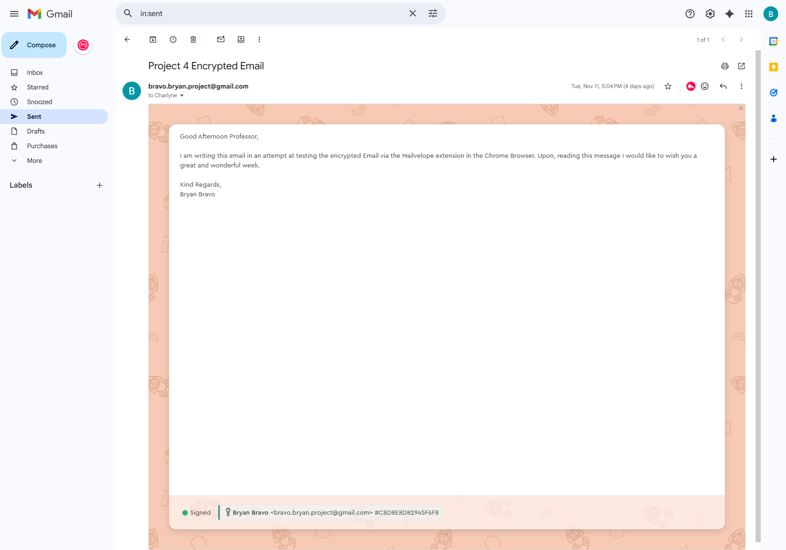
Message Sent via Mailvelope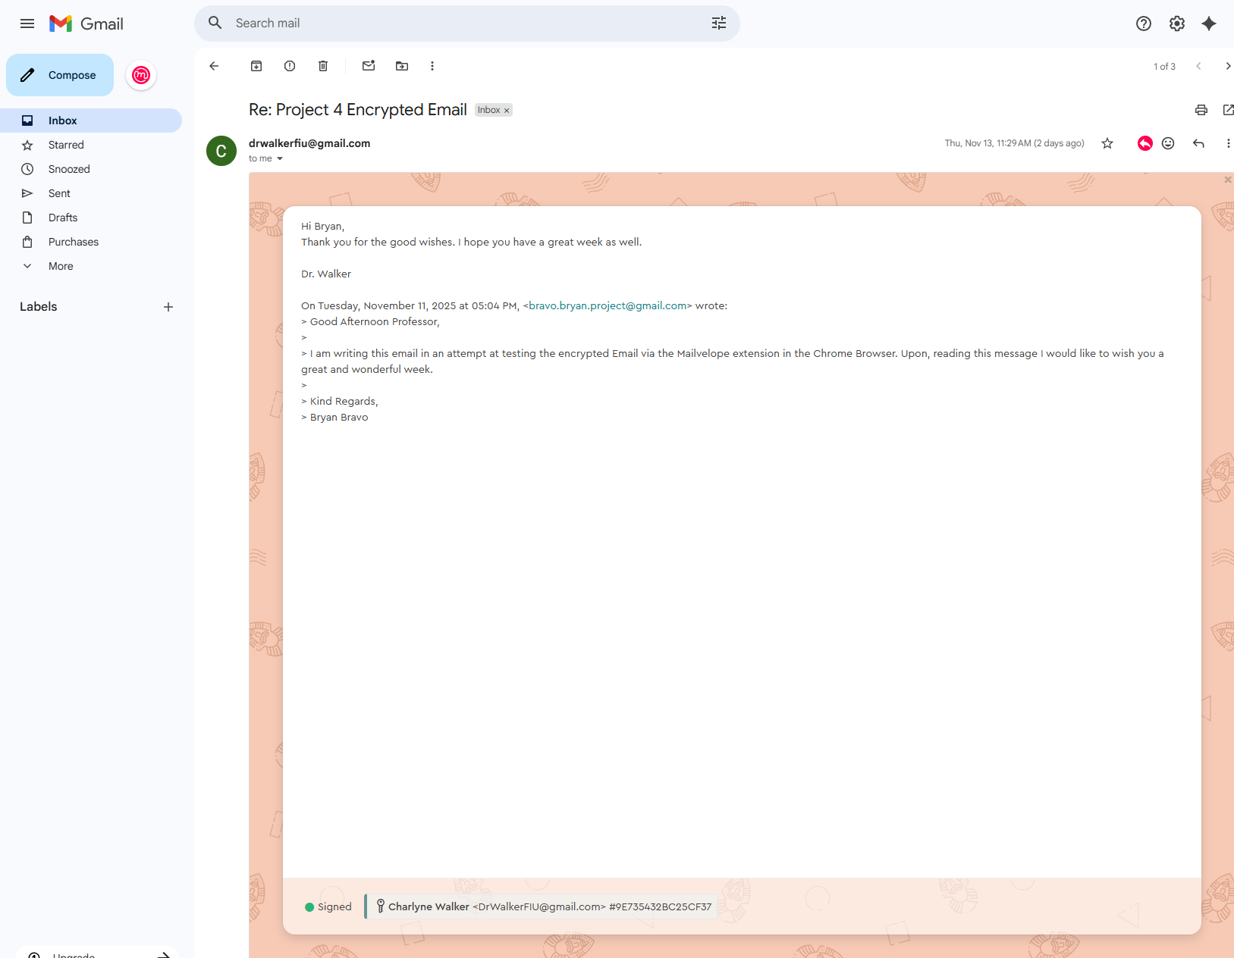

Message Received via Mailvelope
The system used with Mailvelope is OpenPGP. When it comes to how the system is utilized and functions, it widely adopts cryptography in the concept of public-key encryption. This concept works by combining both symmetric and asymmetric cryptography in order to ensure a secure transmission when exchanging messages. According to (Cross, 2025) PGP encryption works in by generating an asymmetric key pair. This key pair is generated before any messages have been sent and received along with this the user would need to generate a public-private key pair in which it is shared with other individuals allowing for the encryption of messages. The private key is then kept secret and is only used to decrypt and sign any incoming messages. Furthermore, after the key pairs and private keys are available a message would be created in which it is still unprotected where it is then assigned a unique symmetric session key that will be used to encrypt messages according to (Cross, 2025). The message is then encrypted using the session key along with using an encryption algorithm such as AES. Once the message is encrypted only the recipient’s private key can decrypt the session key. Once the recipient receives the message, they would use the senders’ public key to verify the signature if the message contained one along with their private key to decrypt the session key. Lastly, this session key is then used to decrypt the contents of the message allowing the recipient to then view the contents of the message.
According to (Dahan, 2025) there are advantages to using a secure email. These advantages are that it can protect information. The example provided by the article is the mention of business of any industry in which they want to maintain the privacy of company data. This can be in the form of financial records, secret information, and trade secrets. Encryption of emails allows for these sensitive documents or data to not end in the hands of unauthorized individuals and are only accessible to the authorized individuals. Other benefits pertaining to secure emails authentication in which it can help individuals and companies in better authenticating actual authentic senders from many malicious actors that decide to send phishing and spam emails. This overall can help prevent attacks and the stealing of keys. Furthermore, many businesses require security in emails due to compliance in many guidelines such as HIPAA, CJIS and CFB in which encryption is required as sensitive information such as student records, medical records, financial data, and credit card information are usually used by many businesses. Lastly, it can also be cost efficient in which the users would not need to purchase equipment or hardware for their network environment in order to ensure security.
Yes, when it comes to using a system like the one provided in the assignment. I can see myself using a version of it at some point in time or a variation of it in a company. This is because there may be an instance in which a sensitive document may need to be sent. This method would ensure that the sensitive document was sent, and while encrypted would ensure that the recipient had received the message containing the document. When it comes to the system in a company environment. It can also be used in the form of authentication in which sensitive private company data can be sent to a recipient and ensure that the sender had in fact sent the message and that it was delivered securely to the intended recipient ensuring that no malicious actors had managed to retrieve said message.

References
Cross, T. (2025, August 16). How to set up and use pretty good privacy (PGP) for Secure Communication. ExpressVPN. https://www.expressvpn.com/blog/pretty-good-privacy/
Dahan, M. (2025). 6 undeniable advantages of email security (2025 edition). https://trustifi.com. https://trustifi.com/advantages-of-email-security/

